CSA 1717-ARTIFICIAL INTELLIGENCE
LAB EXPERIMENT - 8
Abinaya Sri J(192524429)
Aim:
To sum the integers from 1 to n

Algorithm:
Step 1: sum(N, Result) :-
Step 2: N > 0, % Ensuring N is a positive integer
Step 3:N1 is N - 1, % Decrementing N by 1
Step 4:sum(N1, SubResult), % Recursive call to sum the integers from 1 to N1
Step 5:Result is N + SubResult. % Adding N to the sum of integers from 1 to N1 to get the
final result

Program:
sum(0,0). % base case: sum of 0 is 0
sum(N,Sum) :- N > 0, % recursive case: N is positive
N1 is N - 1, % decrement N
sum(N1,Sum1), % recursively compute sum of 1 to N-1
Sum is Sum1 + N. % add N to the sum of 1 to N-1
?- sum(5,Sum).
Sum = 15.
?- sum(10,Sum).
Output:
Sum = 55.
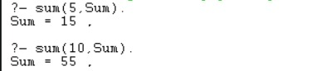

Result:
The above program was executed and output was verified.

